**Topologies**

There are a variety of different topologies in networking. I will be discussing the Star, Bus, Token Ring and Mesh topologies below. A topology is essentially a type of layout for a networking. Different topologies come with different advantages and disadvantages.

**Star**

The star topology is based on a central piece of equipment that handles traffic and transfers it to the other nodes. Each node is connected to the network via a point-to-point connection and is not connected to any other nodes, just the central hub.

[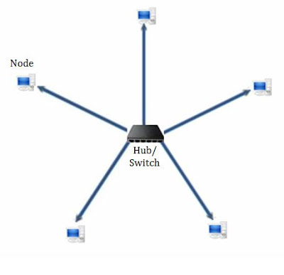](http://4.bp.blogspot.com/-pETOVs0orGo/Tc-fD6t3jUI/AAAAAAAAACo/D6OSdPHrKho/s1600/Star+topology.jpg)

Star topology

Advantages

* Good performance, data isn’t necessarily sent to all nodes, performance is dependent on the capacity of the central hub.
* Easy to connect new nodes/devices, also easy to remove devices. Neither options will have an effect on the rest of the network, e.g. removing a node will not cause the network to crash like it would in other networks.
* Centralised management, help with monitoring
* Failure of a node or link doesn’t effect the rest of the network

Disadvantages

* Too much dependency on central device, if it fails then the network goes down.
* Increased cost for using a hub, switch or a router as a central device
* Performance is dependent on a central device

**Bus**

The bus topology is one of the simplest topologies. All the nodes in the network are connected via a single cable (bus) with the help of interface connectors. The central wire is the backbone of the network, all information passes through this to get to each node. A signal from the source is sent via the bus to all workstations that are connected to it. Although all nodes are sent the data, only the one with the matching MAC/IP address will accept the data. If the addresses of a machine don’t match then the machine discards the signal. A terminator is also added to the ends of the bus to prevent signals bouncing back.

[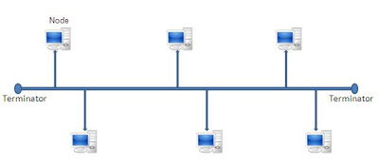](http://3.bp.blogspot.com/-uOcX9Pon2c0/Tcu8C0eq_XI/AAAAAAAAACg/61C7gz0a3F8/s1600/Bus+topology.JPG)

Bus topology

Advantages

* It is easy to setup and also to extend
* The least amount of cabling is required compared with other topologies
* Very cheap to produce
* Useful for small networks, especially LAN networks

Disadvantages

* There is a limit on the length of the bus and therefore the number of nodes that can be connected
* Depending on the central bus can have a few disadvantages, namely if the bus breaks then the entire network will go down.
* Terminators have to be used to dump signals, otherwise traffic will become very large.
* Hard to detect and troubleshoot issues at each individual node
* As the number of nodes increases, the efficiency of the network decreases
* Not suitable for networks with heavy traffic
* Security is low as all nodes receive the sent signal

**Ring Token**

In a ring topology all the nodes in the network are connected to each other in a way that makes a closed loop. Each node connects to the two nodes either side of it and communicates with these two nodes only. Data travels around the network in one direction. Sending and receiving is helped with Token. Token contains information about the destination of the data. When the data packet reaches a node, the node checks if the signal is intended for that node. If it is then it receives the data and passes an empty token to the next node in the network. If the signal is not intended for that node then it is sent on to the next node until it reaches its destination. Only nodes with token are allowed to send data other, nodes have to wait for an empty token to reach them until they can send data. This topology is often found in offices, schools and small buildings.

[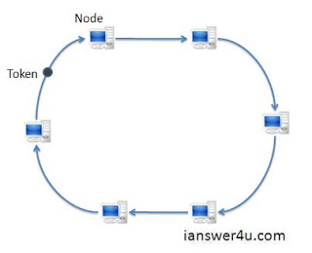](http://1.bp.blogspot.com/-HdZq2BNrAT0/TdOBIVxamkI/AAAAAAAAADY/BaSRNjd2Evg/s1600/Ring_topology_diagram.JPG)

Ring topology with token

Advantages

* Very organized, each node sends data when it receives an empty token. This reduces collisions.
* All traffic flows in one direction at very high speeds
* Even when the load increases, its performances is much better than that of a bus topology.
* There is no need for a network server to control the connectivity between workstations nor is there need for a central hub.
* Additional components do not affect the performance of the network
* Each node has equal access to resources

Disadvantages

* All packets of data have to pass through all the computers between the source and destination which makes it slower than a star topology
* If one workstation or port goes down then the entire network becomes affected
* The network is highly dependent on the wire which connects each component. If there is a fault with this, just like in a bus topology, then the network will go down.
* Network cards are expensive compared to Ethernet cards and hubs

**Mesh**

In a mesh topology, each of the network nodes, computer and other devices, are interconnected with each other. Every node sends its own signals as well as relays data from other nodes. A true mesh topology is where every node is connected to every other node in the network. This is very expensive as it makes many connections redundant. It is more often used in wireless networks as opposed to wired networks.

[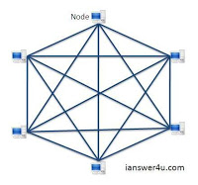](http://1.bp.blogspot.com/-SS6X6E3TGLw/TdTIcZ09OcI/AAAAAAAAADg/KwSmtJali6w/s1600/mesh_topology_diagram.JPG)

Mesh topology

Advantages

* Data can be transmitted from different nodes simultaneously.
* Can withstand high amounts of traffic
* If one component fails, there is always an alternative. In this way data transfer is unaffected.
* Expansion and modification can be done without disrupting other nodes

Disadvantages

* There are high chances of redundancy in many of the connections
* Overall cost of this network is way too high compared with the other topologies
* Setup and maintenance of this topology is difficult, even administration of the network is hard.